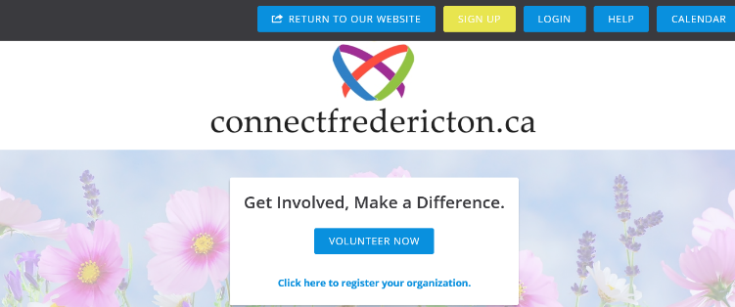
STEP 1: Go to the website - https://www.connectfredericton.ca/

Click on the SIGN UP button at the top of the page.
To change the language to French, go to the bottom of any page on the website to find ENGLISH, click on it to choose your preferred language.
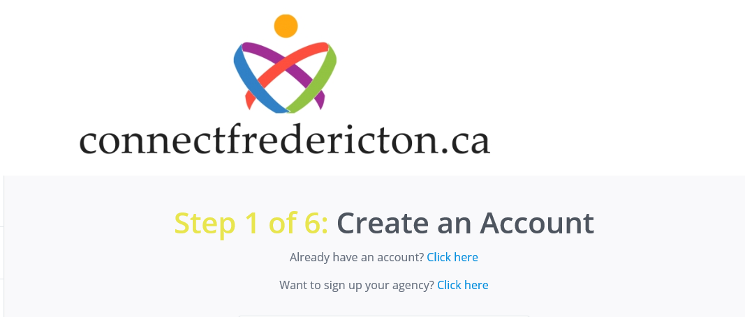

STEP 2: You can sign up through Facebook OR
Fill in the fields to Create an Account.
Some of the fields are required: First Name, Last Name, Address, Postal Code and a Password.

Click on the CREATE YOUR ACCOUNT button.
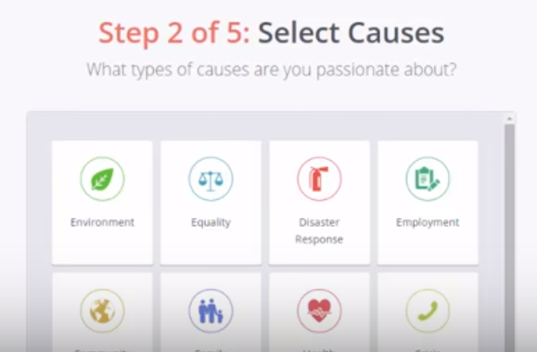

STEP 3: Select Causes.

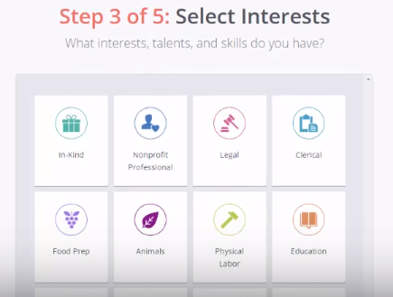

STEP 4: Select Interests.
Click on at least 3 interests, talents and skills you have.

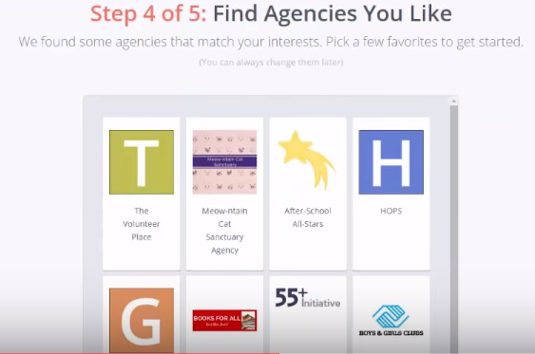

STEP 5: Find Agencies You Like (Optional)

Then click on the FINISH SIGN UP button.
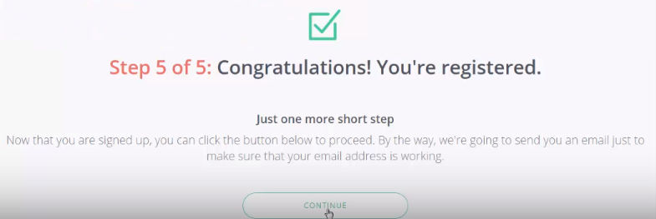
You will receive a Congratulations message saying you are registered and that you will receive an email from
no-reply@galaxydigital.com saying you are registered to ensure your email is working.

Just one more short step…Click on the CONTINUE button. You will be taken to the Dashboard where it shows you everything you have entered into the system.

When an opportunity to volunteer arises, you will receive an email from no-reply@galaxydigital.com with a list of current Needs. If you are interested, click on one of the Needs. You will be taken to the website https://www.connectfredericton.ca/ where you will see a description of the Need.
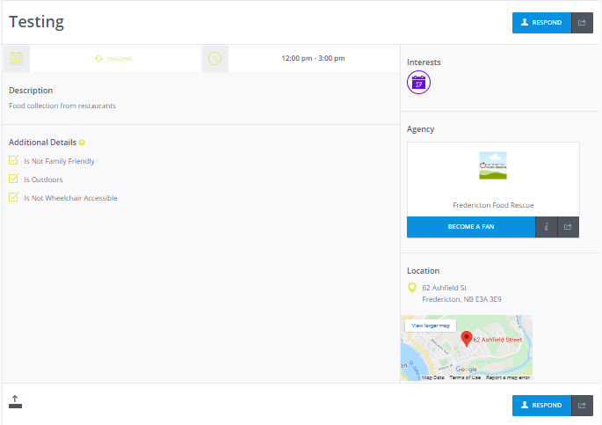

STEP 1: Review the details of the Need. If you are still interested, click on the one of the RESPOND buttons.
OR
If you are not interested, simply leave the website.

STEP 2: When you click on the RESPOND button, you may be asked to login to the connectfredericton.ca website.
Click on the LOGIN button then enter your information.

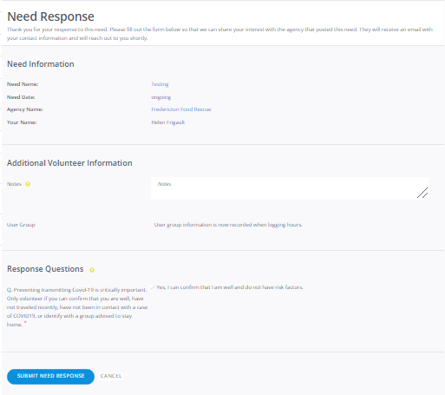
STEP 3: Once you login, you will be taken to the Need Response page:
- Review the Need Information;
- Add any additional information if you wish; then
- If the answer is “yes” to all of the Response Questions click on the button “Yes, I can confirm that I am well and do not have risk factors.”

Click on the SUBMIT NEED RESPONSE button.

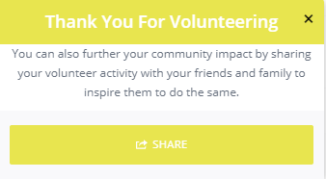

A ‘thank you’ message will appear.
You have an opportunity to share on social media if you wish.

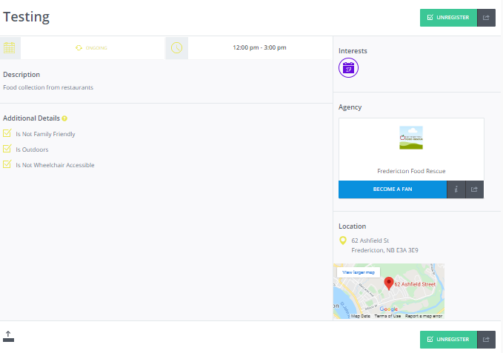
THAT’S IT!
A box shows a summary of the Need.
You will receive an email from no-reply@galaxydigital.com thanking you for your interest and someone from the agency will be in touch with you soon about the volunteer opportunity.
OR

If change your mind about volunteering for this Need you can click on either of the UNREGISTER buttons on this page.

